Software Requirements Specification Report

Team LER: Amazon Alexa O&M Skill

Eric Schulze, Ryan Gosling, Larome Dickerson

Software Requirements Specification Report

Team LER: Amazon Alexa O&M Skill

Eric Schulze, Ryan Gosling, Larome Dickerson

2017

**Table of Contents**

1. Product ……………………………………………………………………………………………………2

2. Technical Feasibility ………………………………………………………………2

3. Social Feasibility ………………………………………………………………………2

4. Economic Feasibility …………………………………………………………………3

5. Market Research ………………………………………………………………………………3

6. Alternative Solution …………………………………………………………………4

7. Project Risks ……………………………………………………………………………………4

8. Conclusion ……………………………………………………………………………………………4

**1. Purpose**

The American Printing House for the Blind (APH) is the world’s largest company devoted to manufacturing, researching, and developing products for people who are blind or visually impaired. APH designs and manufactures textbooks and magazines in braille, large print, and digital formats, as well as other educational, recreational, and daily living products, one of which we have been tasked to develop. APH has requested our services to develop a skill for Amazon’s Alexa voice interface platform.

This skill will consist of a trivia game in which the subject of Orientation and mobility (O&M) will be the focus. The O&M trivia game will be used in concurrence with the training, and education provided to the visually impaired through all stages of life. Blindness or visual impairment can happen to an individual through different stages of their life, from birth to old age, and learning through engagement will solidify the skills they will need to survive in a visual based world, which this Alexa skill will provide.

1a. Glossary

APH: American Print House for the Blind, our project sponsor

O&M: Orientation and Mobility, a subject of instructional lessons for the visually impaired that APH works with

Skill: A capability of Alexa, the Amazon cloud based service that handles speech recognition, machine learning, and natural language understanding, that defines how you can interact with Alexa.

Interaction Model: The Voice User Interface (VUI) of the skill, it defines what functionalities or behaviors the skill is able to handle

Hosted Service: The programming logic of the skill, hosted by Amazon Lambda Services, that responds to a user’s requests and phrases

Utterance: A phrase from the user that the skill can understand and map to an intent

Intent: A representation of functions that the skill is capable of performing. Multiple utterances can map to one intent that then gets passed on to the Hosted Service.

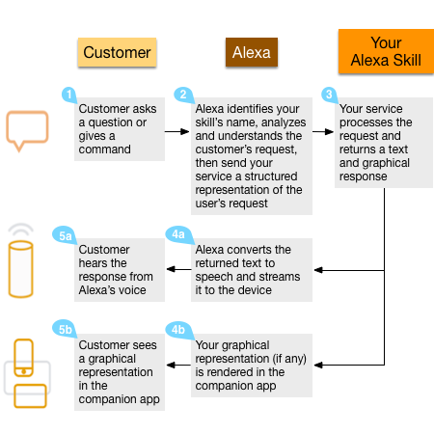1b. System Overview

The Alexa skill will consist of two individual parts working in tandem with each other, the Interaction Model and the Hosted Service. The Interaction Model is a voice user interface (VUI) for the Alexa skill. The Interaction Model is to the skill, what a graphical user interface is to a mobile application; it defines how a user is able to interact with our skill. This Interaction model includes the intents and utterances that a user can use. The intents and utterances trigger responses based on the second part of the skill, the Hosted Service. The hosted service is the brains behind how Alexa handles responses and phrases from the user. The hosted service takes as input intents, deciphered from the user utterance by the VUI, and outputs response phrases.

1c. References

Amazon Alexa Skills Kit (<https://developer.amazon.com/alexa-skills-kit>)

Alexa Skills Documentation (<https://developer.amazon.com/public/solutions/alexa/alexa-skills-kit/overviews/understanding-custom-skills>)

Codecademy – Build Alexa Skills (<https://www.codecademy.com/learn/learn-alexa>)

**2. Product Descriptions**

2a. System Interfaces

The APH O&M Skill interfaces with the Amazon Alexa devices and applications through the Amazon Alexa service and the Lambda Amazon Web Service. The Lambda service will host our code for the Hosted Service and get called by the Amazon Alexa service whenever our skill is requested.

2b. User Interfaces

Users will interact with the APH O&M Skill through the Amazon Alexa Service. There will be a number of invocation functions and in-skill functions (See Product Function). All functions will be accessed through the VUI or Interaction Model.

2c. Hardware Interfaces

The APH O&M Alexa Skill will work on any device that supports the Amazon Alexa service. This can include Amazon Echo, Show, Link devices, as well as the Alexa mobile application for iOS and Android operating systems. The Alexa service will provide all hardware support for these devices.

2d. Software Interfaces

The APH O&M Skill interfaces with the Amazon Alexa devices and applications through the Amazon Alexa service and the Lambda Amazon Web Service. The Lambda service will host our code for the Hosted Service and get called by the Amazon Alexa service whenever our skill is requested.

The skill will also interface with a database of question

2e. Communication Interfaces

2f. Product Functions

3 stages:

Outside of Skill: Start Skill (goes to main menu), Start New Games, Resume paused games

From Main Menu: Start New Game, Resume paused game, Exit skill

Inside a Game: Exit game (goes to main menu, does not save game), Pause game (goes to main menu, does save game), Exit skill

**3. Constraints**

3a. Design Constraints

Only VUI cues.

No memory on device.

3b. Other Constraints, Assumptions, Dependencies

Fully, 100% dependent on Amazon service. Cannot run if amazon site goes down.

**4. Specific Requirements**

4a. External Interface Requirements

Communicate with database to save state.

Communicate with database to get questions and answers and sound files.

4b. Functional Requirements

Needs to play sound files

Needs multiplayer access

Set different difficulties for different players

Have multiple choice and true/false questions

4c. Maintainability

Be able to update questions easily.